|  |  |
| --- | --- |
| **Experiment Number** | **08** |
| **Date of Experiment** | 06/11/2023 |
| **Date of Submission** | 20/11/2023 |
| **Name of the student** | **MANODEEP RAY** |
| **Roll Number** | **2230028** |
| **Section** | ECS-01 |

**Aim of The Experiment :-**

Analysis of the signals generated by sensor interfacing with using Arduino Board / Raspberry Pi.

**Equipment and Software Required:-**

The Equipment and Software required are as follows:

* Arduino Uno R3
* Peizo
* LED
* TMP36
* Potentiometer
* Resistor
* Breadboard - Small
* LCD 16x2
* Arduino IDE

**Code:**

#include <LiquidCrystal.h>

int sensor = A0;

float temp;

float tempc;

float tempf;

#define greenLED 8

#define yellowLED 9

#define redLED 10

LiquidCrystal lcd (12, 11, 5, 4, 3, 2);

void setup () {

pinMode(9, OUTPUT);

pinMode(10, OUTPUT);

pinMode(8, OUTPUT);

pinMode(13, OUTPUT);

lcd.begin (16, 2);

}

void loop () {

temp=analogRead(sensor);

tempc=(temp*4.88)/10;

tempf=(tempc*1.8)+32;

if (tempf < 230){

lcd.setCursor(0,0);

lcd.print("Temp in C = ");

lcd.println(tempc);

lcd.setCursor(0,1);

lcd.print("Temp in F = ");

lcd.println(tempf);

}

else {

digitalWrite(13 ,HIGH);

lcd.setCursor(0,0);

lcd.print("WARNING !!!");

lcd.println("WARNING !!!");

lcd.setCursor(0,1);

lcd.print("WARNING !!!");

lcd.println("WARNING !!!");

}

if (tempf >= 212) {

digitalWrite(greenLED, LOW);

digitalWrite(yellowLED, LOW);

digitalWrite(redLED, HIGH);

}

else if (tempf >= 50 && tempf < 212) {

digitalWrite(greenLED, LOW);

digitalWrite(yellowLED, HIGH);

digitalWrite(redLED, LOW);

}

else {

digitalWrite(greenLED, HIGH);

digitalWrite(yellowLED, LOW);

digitalWrite(redLED, LOW);

}

}

**BlockDiagram:**

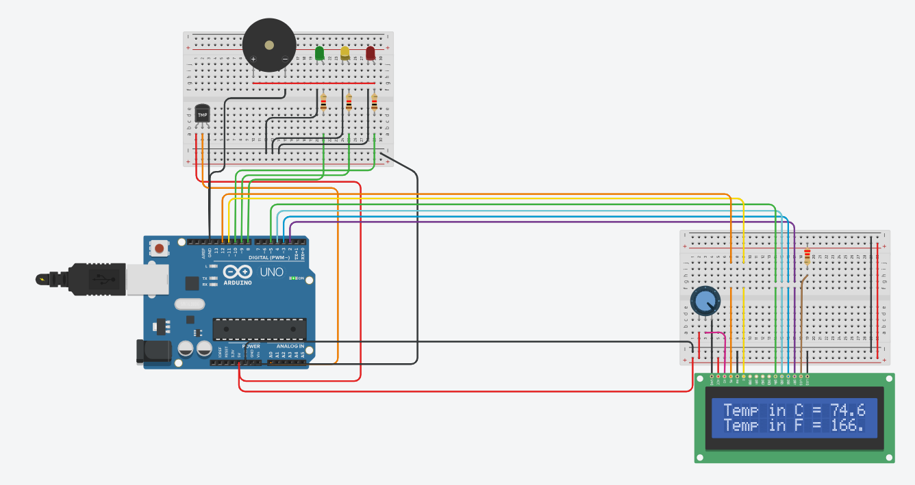

**Discussion or Inference of the experiment:**

In this experiment , we used Arduino Uno R3, Peizo, LEDs, TMP36, Potentiometer, Resistors, and LCD 16x2 to measure room temperature in real time and create a warning system to notify when temp exceeds a certain limit set by us.We used an TMP36 for measuring temperature, used different coloured leds(i.e. red ,yellow and green) to show the levels of temperature, peizo buzzer for warning when the temperature is too high and an LCD screen for displaying the temp in real time.We scripted the code for arduino in Arduino IDE.

**Conslusion:**

This experiment taught us how to use setup a Arduino Uno R3 , connect the kit to the computer and run code on the hardware using Arduino IDE , create a warning system to notify when temp exceeds a certain limit in real-time using the Arduino Uno R3 , use LCD display, Peizo, breadboard and operate on them. We learnt about the function of the Arduino uno and electronic components , and problems regarding them. The circuit can be modified to create warning system , temperature stabilizers , etc for computer systems , indoor gardens botanical gardens etc